UTILIZACION DE PYTHON CON FLASK

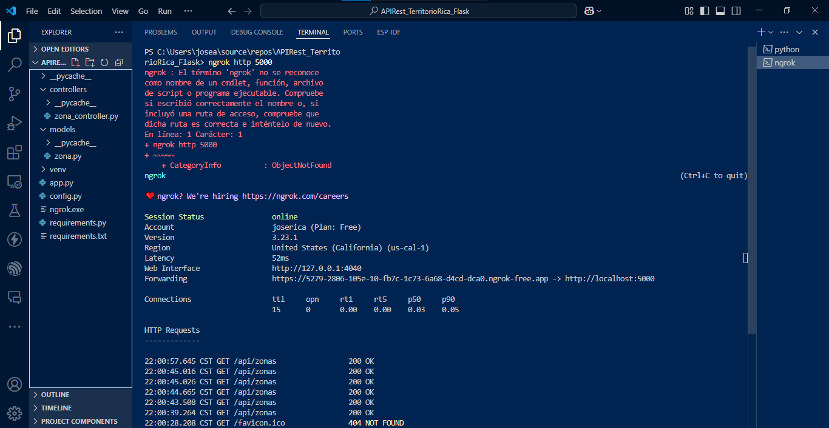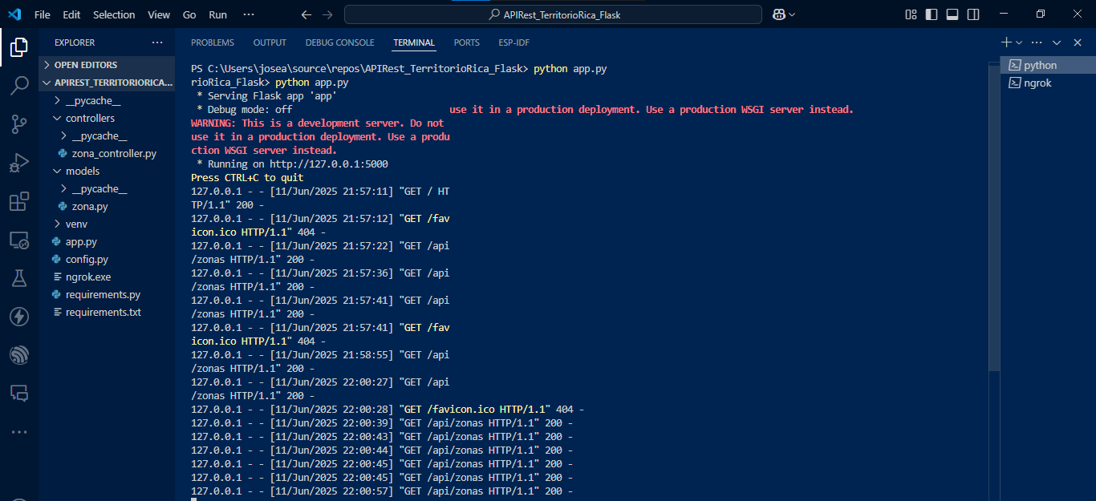

pip install flask

pip install mysql-connector-python

pip install flask flask-cors flask-sqlalchemy

pip freeze > requirements.txt

